***web engineering lab # 3***

***Task # 1: Code*** <!DOCTYPE html>

<html lang="en">

<head>

    <meta charset="UTF-8">

    <meta http-equiv="X-UA-Compatible" content="IE=edge">

    <meta name="viewport" content="width=device-width, initial-scale=1.0">

    <link href="https://cdn.jsdelivr.net/npm/bootstrap@5.1.3/dist/css/bootstrap.min.css" rel="stylesheet" integrity="sha384-1BmE4kWBq78iYhFldvKuhfTAU6auU8tT94WrHftjDbrCEXSU1oBoqyl2QvZ6jIW3" crossorigin="anonymous">

    <title>LAB # 3 "Bootstrap"</title>

    <style>

        .navbar{

            background-color: rgb(0, 225, 255) !important;

        }

        .progress{

            margin: 10px;

        }

    </style>

</head>

<body>

    <nav class="navbar navbar-expand-lg navbar-light bg-light">

        <div class="container-fluid">

          <a class="navbar-brand" href="#">Navbar</a>

          <button class="navbar-toggler" type="button" data-bs-toggle="collapse" data-bs-target="#navbarTogglerDemo02" aria-controls="navbarTogglerDemo02" aria-expanded="false" aria-label="Toggle navigation">

            <span class="navbar-toggler-icon"></span>

          </button>

          <div class="collapse navbar-collapse" id="navbarTogglerDemo02">

            <ul class="navbar-nav me-auto mb-2 mb-lg-0">

              <li class="nav-item">

                <a class="nav-link active" aria-current="page" href="#">Home</a>

              </li>

              <li class="nav-item">

                <a class="nav-link" href="#">Link</a>

              </li>

              <li class="nav-item">

                <a class="nav-link disabled">Disabled</a>

              </li>

            </ul>

            <form class="d-flex">

              <input class="form-control me-2" type="search" placeholder="Search" aria-label="Search">

              <button class="btn btn-outline-success" type="submit">Search</button>

            </form>

          </div>

        </div>

      </nav>

      <h1 class="m-5">

        TASK # 1 : USE "BOOTSTRAP FEATURE"

      </h1>

      <div>

          <div class="row">

            <div class="col-6 m-auto">

            <div class="progress">

                <div class="progress-bar" role="progressbar" aria-valuenow="0" aria-valuemin="0" aria-valuemax="100"></div>

              </div>

              <div class="progress ">

                <div class="progress-bar bg-success progress-bar-striped" role="progressbar" style="width: 25%" aria-valuenow="25" aria-valuemin="0" aria-valuemax="100"></div>

              </div>

              <div class="progress">

                <div class="progress-bar bg-danger" role="progressbar" style="width: 50%" aria-valuenow="50" aria-valuemin="0" aria-valuemax="100"></div>

              </div>

              <div class="progress">

                <div class="progress-bar bg-warning" role="progressbar" style="width: 75%" aria-valuenow="75" aria-valuemin="0" aria-valuemax="100"></div>

              </div>

              <div class="progress">

                <div class="progress-bar" role="progressbar" style="width: 100%" aria-valuenow="100" aria-valuemin="0" aria-valuemax="100"></div>

              </div>

          </div>

        </div>

      </div>

***OUTPUT:*** 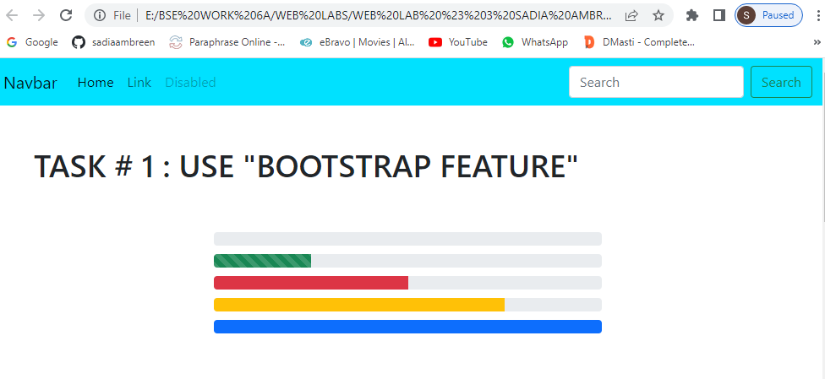

***Task # 2: Code*** <!--TASK # 2-->

      <h1 class="m-5">Task # 02: Create the “PAGINATION” tool of Bootstrap:</h1>

      <nav aria-label="Page navigation example">

        <ul class="pagination">

          <li class="page-item"><a class="page-link" href="#">Previous</a></li>

          <li class="page-item"><a class="page-link" href="#">1</a></li>

          <li class="page-item"><a class="page-link" href="#">2</a></li>

          <li class="page-item"><a class="page-link" href="#">3</a></li>

          <li class="page-item"><a class="page-link" href="#">4</a></li>

          <li class="page-item"><a class="page-link" href="#">Next</a></li>

        </ul>

      </nav>

      <!--  -->

      <nav aria-label="Page navigation example">

        <ul class="pagination">

          <li class="page-item">

            <a class="page-link" href="#" aria-label="Previous">

              <span aria-hidden="true">&laquo;</span>

            </a>

          </li>

          <li class="page-item"><a class="page-link" href="#">10</a></li>

          <li class="page-item disabled"><a class="page-link" href="#">11</a></li>

          <li class="page-item"><a class="page-link" href="#">12</a></li>

          <li class="page-item">

            <a class="page-link" href="#" aria-label="Next">

              <span aria-hidden="true">&raquo;</span>

            </a>

          </li>

        </ul>

      </nav>

     <div class="container-fluid">

         <div class="row">

            <div class="col-3 m-auto">

                <nav aria-label="Page navigation example">

                    <ul class="pagination">

                      <li class="page-item">

                        <a class="page-link" href="#" aria-label="Previous">

                          <span aria-hidden="true">&#8592;</span>

                        </a>

                      </li>

                      <li class="page-item"><a class="page-link" href="#">10</a></li>

                      <li class="page-item disabled"><a class="page-link" href="#">11</a></li>

                      <li class="page-item"><a class="page-link" href="#">12</a></li>

                      <li class="page-item">

                        <a class="page-link" href="#" aria-label="Next">

                          <span aria-hidden="true">&#8594;</span>

                        </a>

                      </li>

                    </ul>

                  </nav>

            </div>

         </div>

         <div class="row">

             <div class="col ">

                <nav aria-label="Page navigation example " >

                    <ul class="pagination rounded-circle  justify-content-center">

                      <li class="page-item  rounded-circle m-2"><a class="page-link rounded-circle" href="#">Previous</a></li>

                      <li class="page-item m-2"><a class="page-link rounded-circle" href="#">Next</a></li>

                    </ul>

                  </nav>

             </div>

         </div>

     </div>

     <nav aria-label="Page navigation example " >

        <ul class="pagination rounded-circle  ">

          <li class="page-item  rounded-circle m-2"><a class="page-link rounded-circle" href="#">&#8592;Older</a></li>

        </ul>

      </nav>

***OUTPUT:*** 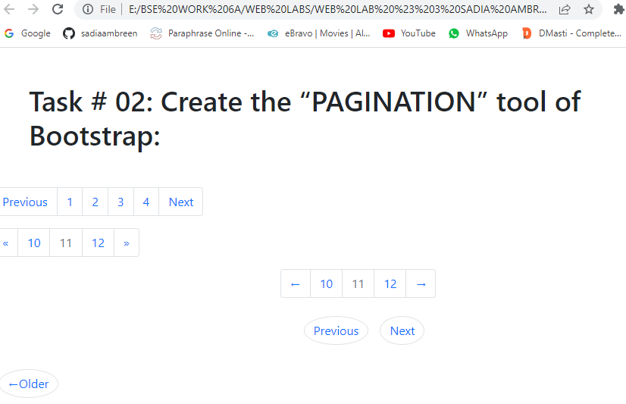

***Task # 3: Code***  <!-- TASK # 3 -->

      <h1 class="m-5">

        TASK # 3 : "USE CONCEPT OF ALERTS IN BOOTSTRAP"

      </h1>

<div class="containers p-3">

    <div class="alert alert-warning alert-dismissible fade show" role="alert">

        <strong>Holy guacamole!</strong> Best check yo self.Youre no <strong>looking too good</strong>

      </div>

      <div class="alert alert-danger alert-dismissible fade show" role="alert">

        <strong>Oh snap!</strong> Change this and that and <strong>try again.</strong>

      </div>

      <div class="alert alert-success alert-dismissible fade show" role="alert">

        <strong>Well done!</strong> You succesfully <strong>read this </strong> alert message

      </div>

      <div class="alert alert-info alert-dismissible fade show" role="alert">

        <strong>Heads up!</strong> This is an alert that needs your attention,but its not a <strong>huge priority</strong> just yet.

       </div>

</div>

***OUTPUT:*** 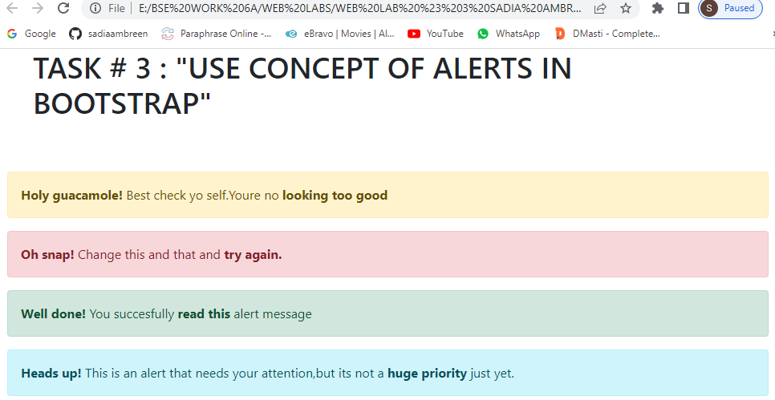

***Task # 4: Code*** <!-- TASK # 4 -->

<h1 class="m-5">

    TASK # 4 :"CREATE FORM BY USING BOOTHSTRAP FOR DESIGNING ..USE JS AND HTML VALIDATION FOR VALIDATING THE FORM INPUTS"

  </h1>

<form class="row g-3 p-3">

    <div class="col-12">

      <label for="inputEmail4" class="form-label h3">Company name</label>

      <input type="email" class="form-control" id="inputEmail4">

    </div>

    <div class="col-12">

      <label for="inputPassword4" class="form-label h3">Phone</label>

      <input type="number" class="form-control" id="inputPassword4" placeholder="123-456-7890">

    </div>

    <div class="col-12">

      <label for="inputAddress" class="form-label h3">Website</label>

      <input type="text" class="form-control" id="inputAddress" placeholder="https://">

    </div>

    <div class="col-12">

      <button type="submit" class="btn btn-secondary">Send Form</button>

    </div>

  </form>

      <script src="https://cdn.jsdelivr.net/npm/bootstrap@5.1.3/dist/js/bootstrap.bundle.min.js" integrity="sha384-ka7Sk0Gln4gmtz2MlQnikT1wXgYsOg+OMhuP+IlRH9sENBO0LRn5q+8nbTov4+1p" crossorigin="anonymous"></script>

</body>

</html>

***OUTPUT:*** 